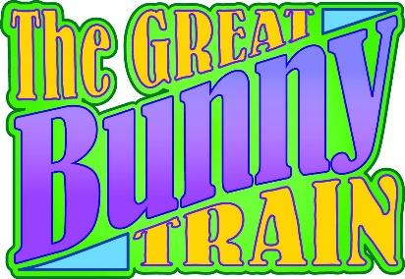

**Frequently Asked Questions**

**Updated 4/1/2025**

* **The event will take place from April 12-13, 2025, rain or shine. The Museum will be open from 9 am-5 pm on each day of the event. Tickets go on sale on Friday, January 10th, 2025 – there will be tickets available at the gate.**
* **Standard tickets are $20 each, and every attendee over 2 needs to have a ticket.** Attendees will choose between the **Josephine and Bi-Level cars** as their Standard ticketing option**. The only timed event for the day is their train ride – families can feel free to stay all day to explore and participate in our activities!**
* **Premium tickets are $27 each, and every rider requires this ticket, regardless of age.** Premium ticket holders will get to ride the train with the Easter Bunny and enjoy some sweet treats and refreshments on the ride, as well as receiving some special items to take home. *(As of 4/1/24, Premium tickets are sold out for 4/12 and there are a limited number available for 4/13)*.
* **Coupon Codes** for Great Bunny Train include **TGBTrain25**, which will get members $2 off standard tickets. Lifetime and Station Master members will receive free standard ticket vouchers via mail.
* Train rides are at **9:30 am, 10:15 am, 11:00 am, 11:45 am, 1:30 pm, 2:15 pm, 3:00 pm, and 3:45 pm. *Premium train rides will be at 10:15 am, 11:45 am, 2:15 pm and 3:45 pm.***
* The Easter Bunny will be available in the Lenfestey Center at **9:30 am, 10:30 am, 11:30 am, 12:30 pm, 1:30 pm, 2:30 pm, 3:30 pm, and 4:30 pm.** Each visit will last 30 minutes (and then the bunny will take a carrot break)!
* **Food and Beverages will be catered by Dos Chiles, and Travelin’ Tom’s Coffee Truck** will be parked outside of the Children’s Depot!
* **Activities** include Plant A Bean Seed, Easter Bean Bag Throw or Carrot Ring Toss. **Crafts** include Paper Easter Egg Decorating, Build a Beaded Egg, and Paper Plate Easter Bunny. You can get your own balloon animal from Mischief & Magic, get a temporary tattoo, or try your hand at the 7-Up Coloring Contest! You will be able to collect eggs and turn them in at our Egg Turn-In station for a cool surprise!
* **Entertainment** will be provided by Jeff McMullen. Join us in our Lenfestey Center twice per day for two special sessions of Bingo and two Egg Roll Contests!

**Please forward any questions outside of this info directly to Liz at 920-274-0539 or via e-mail at lvanpay@nationalrrmuseum.org.**